Week-8 (DAY-3) – Handson – Keerthivasan R

📌 Problem Statement
Traditional monolithic applications combine all business functionalities such as user management, product management, orders, payments, and reporting into a single codebase. As the application grows, this architecture leads to:
- Difficulty in scaling individual modules
- Slow deployment cycles
- Tight coupling between components
- Reduced fault isolation (failure in one module affects entire system)
- Harder maintenance and testing
- Limited technology flexibility
Modern businesses require scalable, flexible, and independently deployable systems to handle increasing users and complex business operations.
To address these challenges, the application must be redesigned using a Microservices Architecture.

🎯 Project Objective
Design and develop a microservices-based system using ASP.NET Core where:
- Each business module is developed as an independent service
- Services communicate via REST APIs
- Each service has its own database
- Authentication is handled centrally using JWT
- Services can be deployed and scaled independently

🛠 Proposed Microservices
Example system (E-Commerce or Enterprise Management):
- User Service
  - Registration & Login
  - JWT Token Generation
- Product Service
  - Add, Update, Delete Products
  - Product Listing
- Order Service
  - Place Orders
  - Track Order Status
- Payment Service
  - Handle Payments
  - Transaction Records
- API Gateway
  - Single entry point for all services
  - Routes requests to appropriate microservices

📌 Functional Requirements
- Independent services with separate databases
- Inter-service communication using HTTP
- Secure APIs using JWT Authentication
- Proper error handling and logging
- API Gateway implementation

📌 Non-Functional Requirements
- Scalability
- Fault isolation
- Independent deployment
- High availability
- Security

📌 Expected Outcome
The final system should:
- Allow services to run independently
- Scale specific services based on load
- Ensure secure communication between services
- Reduce impact of failure in one service
- Improve maintainability and performance

CODE:
📁 MicroservicesSolution/ appSettings.json
{
"Jwt": {
"Key": "MICROSERVICES_SUPER_SECRET_KEY_1234567890",
"Issuer": "UserService",
"Audience": "Microservices"
},

"Logging": {
"LogLevel": {
"Default": "Information",
"Microsoft.AspNetCore": "Warning"
}
},

"AllowedHosts": "*"
}

MicroservicesSolution/ Program.cs
using Microsoft.AspNetCore.Authentication.JwtBearer;
using Microsoft.IdentityModel.Tokens;
using System.Text;

var builder = WebApplication.CreateBuilder(args);

// Controllers
builder.Services.AddControllers();

// Swagger
builder.Services.AddEndpointsApiExplorer();
builder.Services.AddSwaggerGen(c =>
{
c.AddSecurityDefinition("Bearer", new Microsoft.OpenApi.Models.OpenApiSecurityScheme
{
Name = "Authorization",
Type = Microsoft.OpenApi.Models.SecuritySchemeType.Http,
Scheme = "Bearer",
BearerFormat = "JWT",
In = Microsoft.OpenApi.Models.ParameterLocation.Header
});

c.AddSecurityRequirement(new Microsoft.OpenApi.Models.OpenApiSecurityRequirement
{
{
new Microsoft.OpenApi.Models.OpenApiSecurityScheme
{
Reference = new Microsoft.OpenApi.Models.OpenApiReference
{
Type = Microsoft.OpenApi.Models.ReferenceType.SecurityScheme,
Id = "Bearer"
}
},
new string[] {}
}
});
});

// JWT Authentication
builder.Services.AddAuthentication(JwtBearerDefaults.AuthenticationScheme)
.AddJwtBearer(options =>
{
options.TokenValidationParameters = new TokenValidationParameters
{
ValidateIssuer = true,
ValidateAudience = true,
ValidateLifetime = true,
ValidateIssuerSigningKey = true,

ValidIssuer = builder.Configuration["Jwt:Issuer"],
ValidAudience = builder.Configuration["Jwt:Audience"],
IssuerSigningKey = new SymmetricSecurityKey(
Encoding.UTF8.GetBytes(builder.Configuration["Jwt:Key"]!)
)
};
});

builder.Services.AddAuthorization();

var app = builder.Build();

app.UseSwagger();
app.UseSwaggerUI();

app.UseHttpsRedirection();

app.UseAuthentication(); // MUST be before Authorization
app.UseAuthorization();

app.MapControllers();

app.Run();
MicroservicesSolution/ Controllers/ ProductController.cs
using Microsoft.AspNetCore.Authorization;
using Microsoft.AspNetCore.Mvc;

namespace ProductService.Controllers
{
[Authorize]
[ApiController]
[Route("api/products")]
public class ProductController : ControllerBase
{
[HttpGet]
public IActionResult GetProducts()
{
var products = new[]
{
new { Id = 1, Name = "Laptop", Price = 80000 },
new { Id = 2, Name = "Mobile", Price = 30000 }
};

return Ok(products);
}
}
}
MicroservicesSolution/ Userservice/ Controllers/ AuthController.cs
using Microsoft.AspNetCore.Mvc;
using Microsoft.IdentityModel.Tokens;
using System.IdentityModel.Tokens.Jwt;
using System.Security.Claims;
using System.Text;
using UserService.Data;
using UserService.Models;
using System.Linq;

namespace UserService.Controllers
{
[ApiController]
[Route("api/auth")]
public class AuthController : ControllerBase
{
private readonly UserDbContext _context;
private readonly IConfiguration _configuration;

public AuthController(UserDbContext context, IConfiguration configuration)
{
_context = context;
_configuration = configuration;
}

// REGISTER
[HttpPost("register")]
public IActionResult Register(User user)
{
_context.Users.Add(user);
_context.SaveChanges();
return Ok("User registered successfully");
}

// LOGIN (JWT)
[HttpPost("login")]
public IActionResult Login(User user)
{
var existingUser = _context.Users
.FirstOrDefault(u => u.Username == user.Username
&& u.Password == user.Password);

if (existingUser == null)
return Unauthorized("Invalid username or password");

var claims = new[]
{
new Claim(ClaimTypes.Name, existingUser.Username)
};

var key = new SymmetricSecurityKey(
Encoding.UTF8.GetBytes(_configuration["Jwt:Key"]));

var creds = new SigningCredentials(key, SecurityAlgorithms.HmacSha256);

var token = new JwtSecurityToken(
issuer: _configuration["Jwt:Issuer"],
audience: _configuration["Jwt:Audience"],
claims: claims,
expires: DateTime.Now.AddMinutes(30),
signingCredentials: creds
);

return Ok(new
{
token = new JwtSecurityTokenHandler().WriteToken(token)
});
}
}
}
MicroservicesSolution/ Userservice/ Data/ UserDbContext.cs
using Microsoft.EntityFrameworkCore;
using UserService.Models;

namespace UserService.Data
{
public class UserDbContext : DbContext
{
public UserDbContext(DbContextOptions<UserDbContext> options)
: base(options)
{
}

public DbSet<User> Users { get; set; }
}
}
MicroservicesSolution/ Userservice/ Models/ users.cs
namespace UserService.Models
{
public class User
{
public int Id { get; set; }
public string Username { get; set; }
public string Password { get; set; }
}
}
MicroservicesSolution/ Userservice/ appSettings.json
{
"Jwt": {
"Key": "MICROSERVICES_SUPER_SECRET_KEY_1234567890",
"Issuer": "UserService",
"Audience": "Microservices"
},

"ConnectionStrings": {
"DefaultConnection": "Server=(localdb)\\MSSQLLocalDB;Database=UserServiceDb;Trusted_Connection=True;"
},

"Logging": {
"LogLevel": {
"Default": "Information",
"Microsoft.AspNetCore": "Warning"
}
},

"AllowedHosts": "*"
}
MicroservicesSolution/ Userservice/ Program.cs
using Microsoft.AspNetCore.Authentication.JwtBearer;
using Microsoft.EntityFrameworkCore;
using Microsoft.IdentityModel.Tokens;
using System.Text;
using UserService.Data;

var builder = WebApplication.CreateBuilder(args);

// Controllers
builder.Services.AddControllers();

// DbContext
builder.Services.AddDbContext<UserDbContext>(options =>
options.UseSqlServer(builder.Configuration.GetConnectionString("DefaultConnection")));

// JWT Authentication
builder.Services.AddAuthentication(JwtBearerDefaults.AuthenticationScheme)
.AddJwtBearer(options =>
{
options.TokenValidationParameters = new TokenValidationParameters
{
ValidateIssuer = true,
ValidateAudience = true,
ValidateLifetime = true,
ValidateIssuerSigningKey = true,

ValidIssuer = builder.Configuration["Jwt:Issuer"],
ValidAudience = builder.Configuration["Jwt:Audience"],
IssuerSigningKey = new SymmetricSecurityKey(
Encoding.UTF8.GetBytes(builder.Configuration["Jwt:Key"]))
};
});

// Swagger
builder.Services.AddEndpointsApiExplorer();
builder.Services.AddSwaggerGen();

var app = builder.Build();

// Middleware
if (app.Environment.IsDevelopment())
{
app.UseSwagger();
app.UseSwaggerUI();
}

app.UseHttpsRedirection();

app.UseAuthentication(); // 🔐 IMPORTANT
app.UseAuthorization();

app.MapControllers();

app.Run();
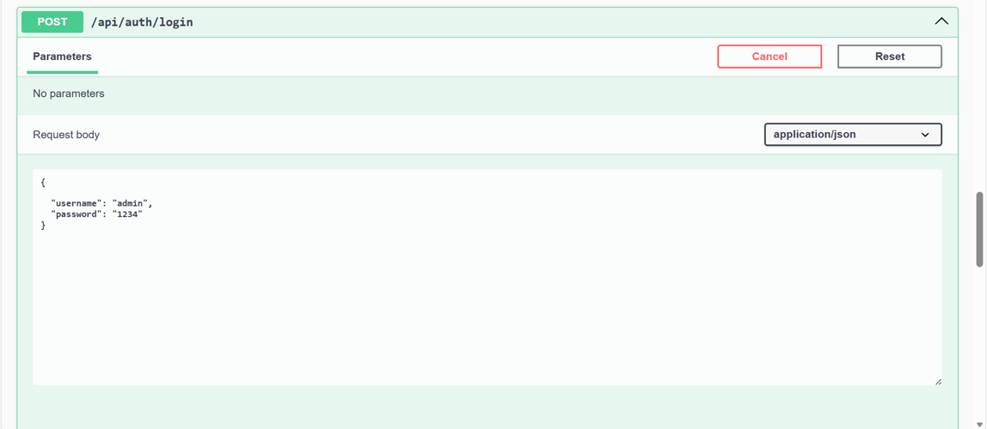
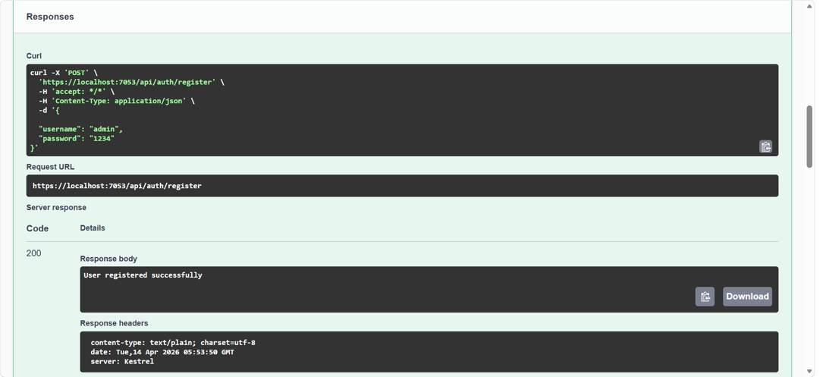
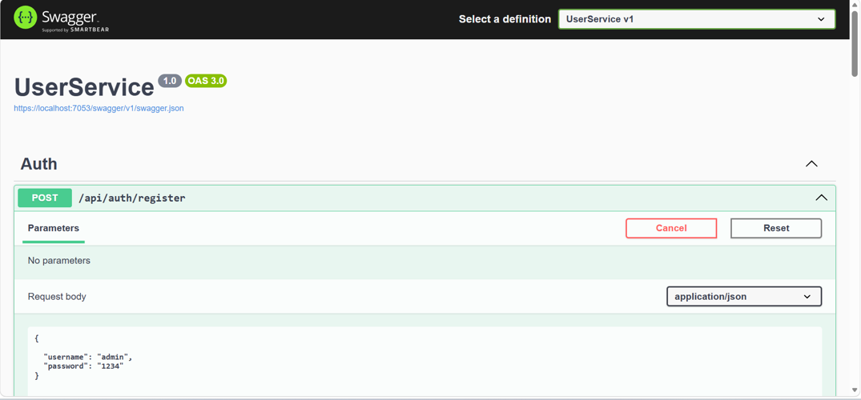
OUTPUT:

